

Batch member

621721243031:Manoranjan.A

3rd year [AI&DS]

Phase 3: Development part I

**TRAFFIC MANAGEMENT SYSTEM USING IOT**

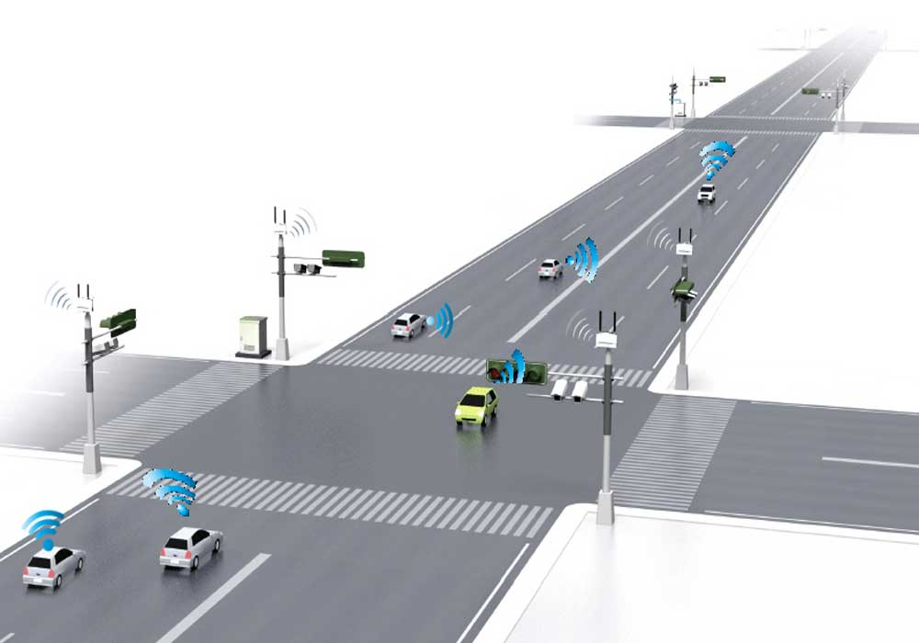

Project: Traffic management system

INTRODUCTION:

A traffic management system using IoT (Internet of Things) leverages interconnected devices and sensors to monitor, analyze, and optimize traffic flow and safety on roads and highways.

IoT technologies enable real-time data collection, analysis, and intelligent decision-making to enhance traffic efficiency, reduce congestion, improve safety, and minimize environmental impact.

This system integrates various components, including sensors, communication devices, data processing systems, and control mechanisms, to create a smart and efficient traffic ecosystem.

The objective is to help commuters Make informed decisions about their routes and alleviate traffic congestion.

This project includes defining objectives, designing the IOT traffic monitoring system, developing the traffic information platform, and integrating them using IOT Technology and python.

Components:

• Radio signal detector

• Radio waves transmitter

• Ultra-sonic sensor/Hall Effect sensor

• Raspberry Pi

• Python programming

• Light Emitting Diode

Given dataset:

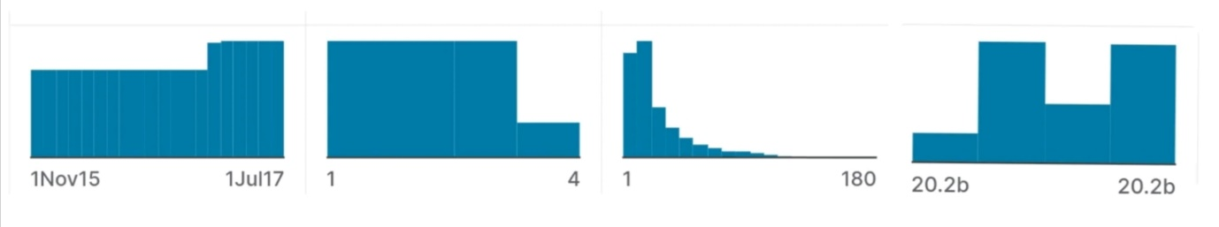

|  |  |  |  |
| --- | --- | --- | --- |
| DateTime | Junction | Vehicles | ID |
|  |  |  |  |
|  |  |  |  |
| 01-11-2015 00:00 | 1 | 15 | 20151101001 |
| 01-11-2015 01:00 | 1 | 13 | 20151101011 |
| 01-11-2015 02:00 | 1 | 10 | 20151101021 |
| 01-11-2015 03:00 | 1 | 7 | 20151101031 |
| 01-11-2015 04:00 | 1 | 9 | 20151101041 |
| 01-11-2015 05:00 | 1 | 6 | 20151101051 |
| 01-11-2015 06:00 | 1 | 9 | 20151101061 |
| 01-11-2015 07:00 | 1 | 8 | 20151101071 |
| 01-11-2015 08:00 | 1 | 11 | 20151101081 |
| 01-11-2015 09:00 | 1 | 12 | 20151101091 |
| 01-11-2015 10:00 | 1 | 15 | 20151101101 |
| 01-11-2015 11:00 | 1 | 17 | 20151101111 |
| 01-11-2015 12:00 | 1 | 16 | 20151101121 |
| 01-11-2015 13:00 | 1 | 15 | 20151101131 |
| 01-11-2015 14:00 | 1 | 16 | 20151101141 |
| 01-11-2015 15:00 | 1 | 12 | 20151101151 |
| 01-11-2015 16:00 | 1 | 12 | 20151101161 |
| 01-11-2015 17:00 | 1 | 16 | 20151101171 |
| 01-11-2015 18:00 | 1 | 17 | 20151101181 |
| 01-11-2015 19:00 | 1 | 20 | 20151101191 |
| 01-11-2015 20:00 | 1 | 17 | 20151101201 |
| 01-11-2015 21:00 | 1 | 19 | 20151101211 |
| 01-11-2015 22:00 | 1 | 20 | 20151101221 |
| 01-11-2015 23:00 | 1 | 15 | 20151101231 |
| 02-11-2015 00:00 | 1 | 14 | 20151102001 |

Dataset link: https://www.kaggle.com/datasets/fedesoriano/traffic-prediction-dataset

Program:

import RPi.GPIO as GPIO

from time import sleep

hallpin1=8

#LED1=8

hallpin2=10

hallpin3=12

#hallpin4=24

hallpin11=22 hallpin12=24

hallpin13=26

hallpin21=38

hallpin22=40

hallpin23=37

hallpin31=31

hallpin32=29

hallpin33=23

LED1=16

LED2=18

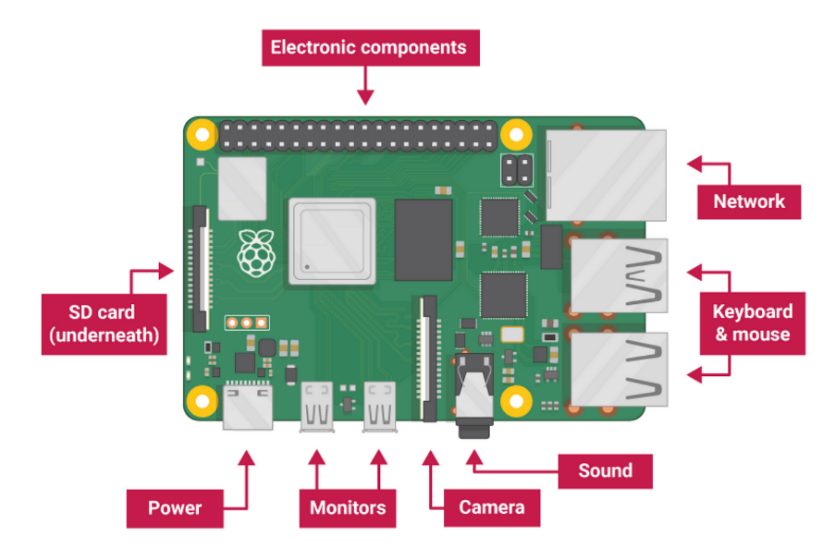 LED11=32

LED12=36

LED21=35

LED22=33

LED31=21

LED32=19

GPIO.setwarnings(False)

GPIO.setmode(GPIO.BOARD)

GPIO.setup(LED1, GPIO.OUT, initial=GPIO.LOW)

GPIO.setup(LED2, GPIO.OUT, initial=GPIO.LOW)

GPIO.setup(hallpin1, GPIO.IN)

#GPIO.setup(LED2, GPIO.OUT, initial=GPIO.LOW)

GPIO.setup(hallpin2, GPIO.IN)

GPIO.setup(hallpin3, GPIO.IN)

GPIO.setup(LED11, GPIO.OUT, initial=GPIO.LOW)

GPIO.setup(LED12, GPIO.OUT, initial=GPIO.LOW)

GPIO.setup(hallpin11, GPIO.IN)

GPIO.setup(hallpin12, GPIO.IN)

GPIO.setup(hallpin13, GPIO.IN)

GPIO.setup(LED21, GPIO.OUT, initial=GPIO.LOW)

GPIO.setup(LED22, GPIO.OUT, initial=GPIO.LOW)

GPIO.setup(hallpin21, GPIO.IN)

GPIO.setup(hallpin22, GPIO.IN)

GPIO.setup(hallpin23, GPIO.IN)

GPIO.setup(LED31, GPIO.OUT, initial=GPIO.LOW)

GPIO.setup(LED32, GPIO.OUT, initial=GPIO.LOW)

GPIO.setup(hallpin31, GPIO.IN)

GPIO.setup(hallpin32, GPIO.IN)

GPIO.setup(hallpin33, GPIO.IN)

while True:

print("-----------------------------")

if(GPIO.input(hallpin1)==True):

# GPIO.output(LED1, GPIO.HIGH)

a1=1 print("magnet 1")

print("detected")

if(GPIO.input(hallpin1)==False):

a1=0 print("magnet 1")

print("not detected")

if(GPIO.input(hallpin2)==True):

a2=1 print(" magnet 2")

print(" detected")

if(GPIO.input(hallpin2)==False):

a2=0 print(" magnet 2")

print("not detected")

if(GPIO.input(hallpin3)==True):

a3=1 print(" magnet 3")

print(" detected")

if(GPIO.input(hallpin3)==False):

a3=0

print("magnet 3")

print(" not detected")

print("---------------------------------")

if(GPIO.input(hallpin11)==True):

b1=1 print("magnet 11")

print("detected")

if(GPIO.input(hallpin11)==False):

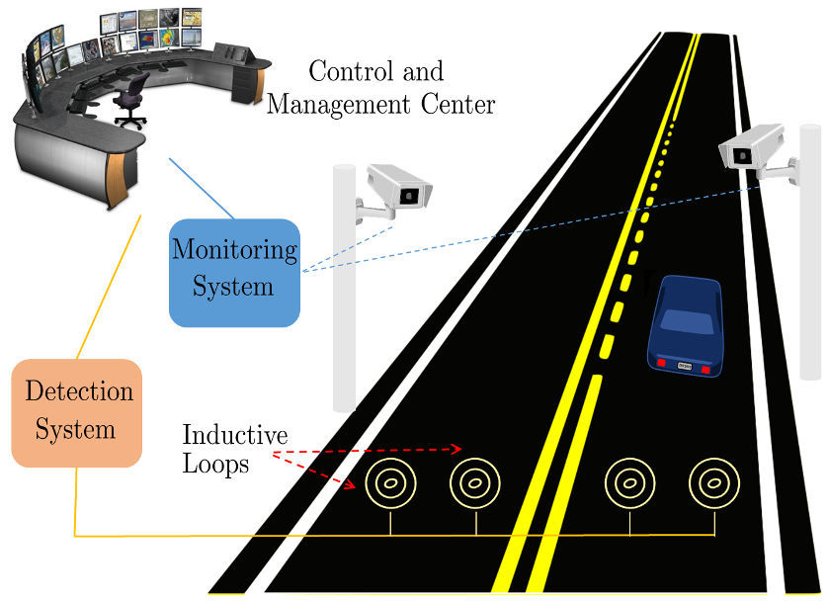 b1=0

print(" magnet 11")

print(" not detected")

if(GPIO.input(hallpin12)==True):

b2=1

print(" magnet 12")

print(" detected")

if(GPIO.input(hallpin12)==False):

b2=0

print(“magnet 12")

print(" not detected")

if(GPIO.input(hallpin13)==True):

b3=1

print(" magnet 13")

print(" detected")

if(GPIO.input(hallpin13)==False):

b3=0 print(" magnet 13")

print(" not detected")

print("------------------------------")

if(GPIO.input(hallpin21)==True):

c1=1

print(" magnet 21")

print(" detected")

if(GPIO.input(hallpin21)==False):

c1=0

print("magnet 21")

print("not detected")

if(GPIO.input(hallpin22)==True):

c2=1

print("magnet 22")

print("detected")

if(GPIO.input(hallpin22)==False):

c2=0

print(" magnet 22")

print("not detected")

if(GPIO.input(hallpin23)==True):

c3=1

print("magnet 23")

print(" detected")

if(GPIO.input(hallpin23)==False):

c3=0

print("magnet 23")

print("not detected")

print("-------------------------------")

if(GPIO.input(hallpin31)==True):

d1=1

print(" magnet 31")

print(" detected")

if(GPIO.input(hallpin31)==False):

d1=0

print(" magnet 31")

print(" not detected")

if(GPIO.input(hallpin32)==True):

d2=1

print(" magnet 32")

print(" detected")

if(GPIO.input(hallpin32)==False):

d2=0

print(" magnet 32")

print(" not detected")

if(GPIO.input(hallpin33)==True):

d3=1

print(" magnet 33")

print(" detected")

if(GPIO.input(hallpin33)==False):

d3=0

print(" magnet 33")

print(" not detected")

sum1=a1+a2+a3

sum2=b1+b2+b3

sum3=c1+c2+c3

sum4=d1+d2+d3

print(sum1)

print(sum2)

print(sum3)

print(sum4)

f1=0 f2=0 f3=0 f4=0

if(f1==1)and(f2==1)and(f3==1)and(f4==1):

f1=0 f2=0 f3=0 f4=0

if(f1==0):

if(sum1>sum2)and(sum1>sum3)and(sum1>sum4):

GPIO.output(LED1, GPIO.HIGH)

GPIO.output(LED12, GPIO.HIGH)

GPIO.output(LED22, GPIO.HIGH)

GPIO.output(LED32, GPIO.HIGH)

sleep(15)

GPIO.output(LED1, GPIO.LOW)

GPIO.output(LED12, GPIO.LOW)

GPIO.output(LED22, GPIO.LOW)

GPIO.output(LED32, GPIO.LOW)

f1=1 if(f2==0):

if(sum2>sum1)and(sum2>sum3)and(sum2>sum4):

GPIO.output(LED11, GPIO.HIGH)

GPIO.output(LED2, GPIO.HIGH)

GPIO.output(LED22, GPIO.HIGH)

GPIO.output(LED32, GPIO.HIGH)

sleep(15)

GPIO.output(LED11, GPIO.LOW)

GPIO.output(LED2, GPIO.LOW)

GPIO.output(LED22, GPIO.LOW)

GPIO.output(LED32, GPIO.LOW)

f2=1

if(f3==0):

if(sum3>sum1)and(sum3>sum2)and(sum3>sum4):

GPIO.output(LED21, GPIO.HIGH)

GPIO.output(LED2, GPIO.HIGH)

GPIO.output(LED12, GPIO.HIGH)

GPIO.output(LED32, GPIO.HIGH)

sleep(15)

GPIO.output(LED21, GPIO.LOW)

GPIO.output(LED2, GPIO.LOW)

GPIO.output(LED12, GPIO.LOW)

GPIO.output(LED32, GPIO.LOW)

f3=1

if(f4==0):

if(sum4>sum1)and(sum4>sum2)and(sum4>sum3):

GPIO.output(LED31, GPIO.HIGH)

GPIO.output(LED2, GPIO.HIGH)

GPIO.output(LED12, GPIO.HIGH)

GPIO.output(LED22, GPIO.HIGH)

sleep(15)

GPIO.output(LED31, GPIO.LOW)

GPIO.output(LED2, GPIO.LOW)

GPIO.output(LED12, GPIO.LOW)

GPIO.output(LED22, GPIO.LOW)

f4=1

sleep(2)

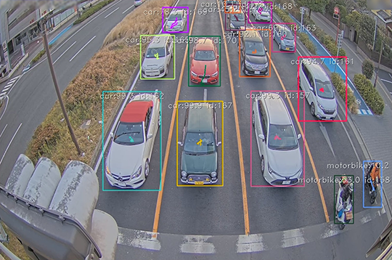

CONCLUSION:

smart traffic management system has given the best results to with waiting & travelling time of a passenger has been reduced and emergency vehicles can move without obstacles or barriers. The pollution rate can be reduced by implementing this smart traffic management system in all prime locations. The suggested traffic management system can be implemented in all metropolitan cities as it is most suitable and reliable for the day.